Internet Application Assessment 1

David Atkins

Contents

Purpose of website 2

Website structure 2

Wireframe 3

Mood Board 6

Inspiration 6

Final design 6

References 7

# Purpose of website

After doing research into different ideas over what I wish the purpose of the website to be, I have decided to make a website centred around selling different biking products. This will range from selling various different kinds of bikes such as road and mountain bikes to selling different gear that a biker may want, from helmets to repair kits. The main target market for this website will be bike enthusiasts and people who may want to be getting into some form of biking. Due to this I need to make sure that my website is both friendly towards the more experienced bikers and the newer bikers.

# Website structure

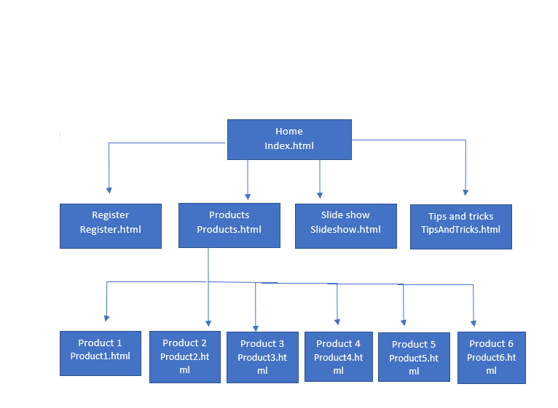

# Wireframe

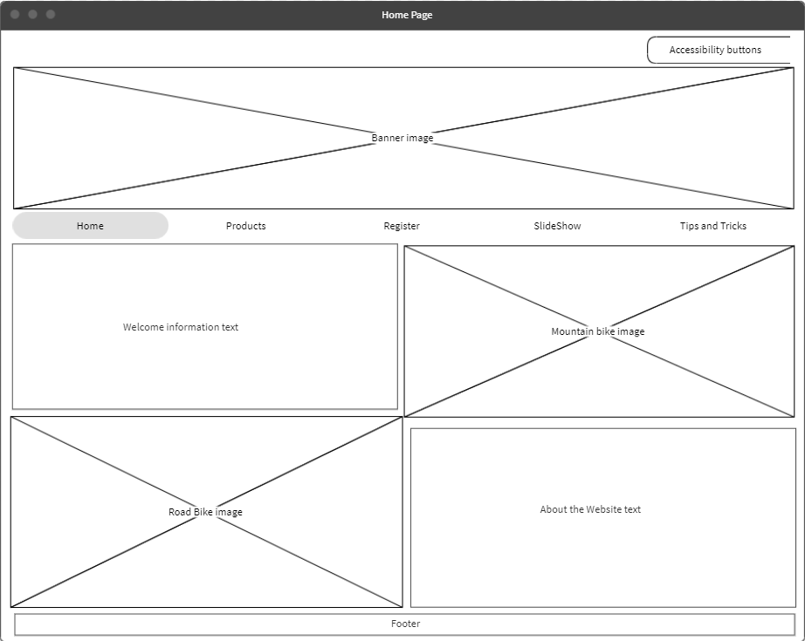

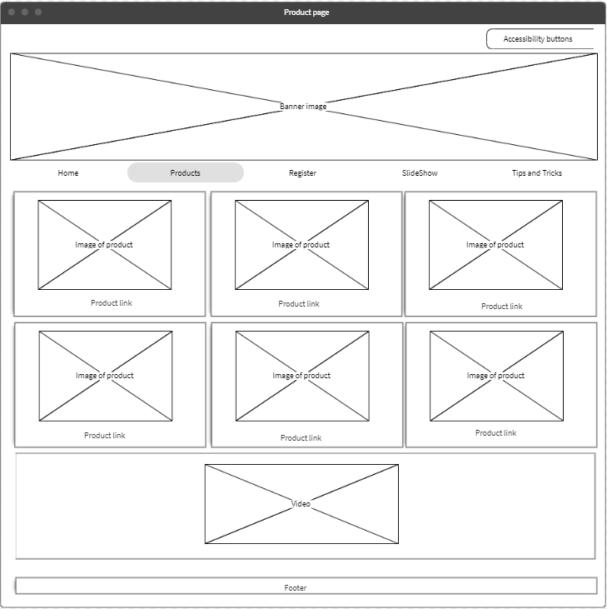

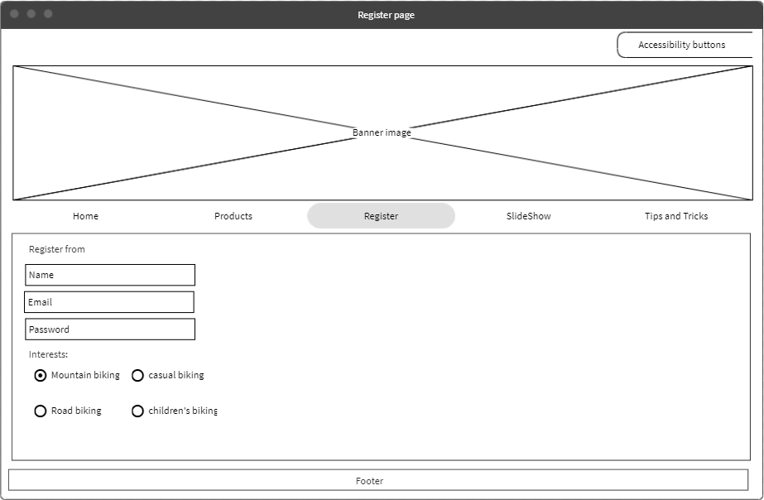

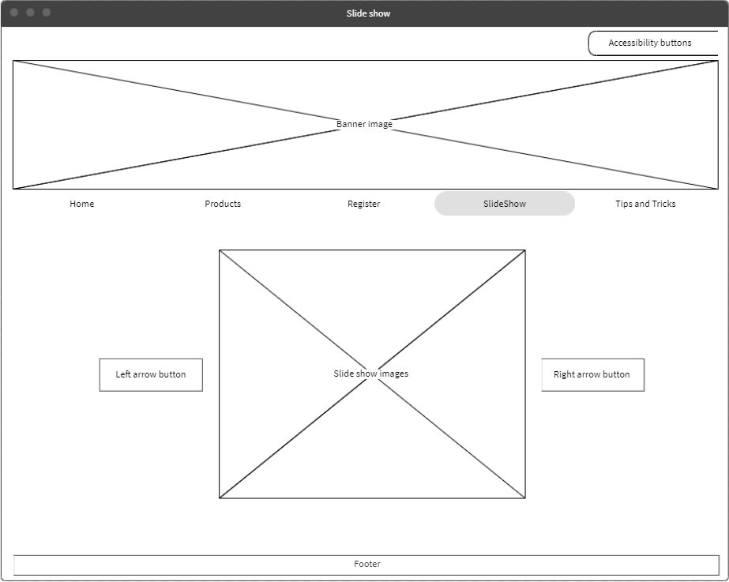

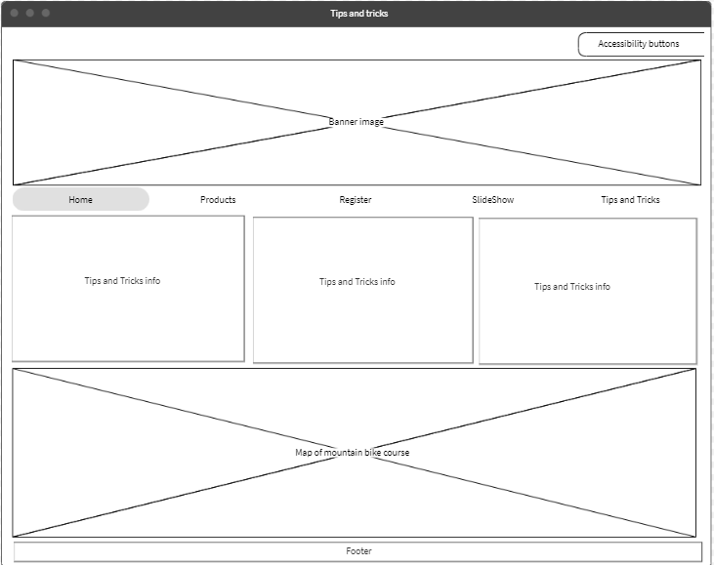

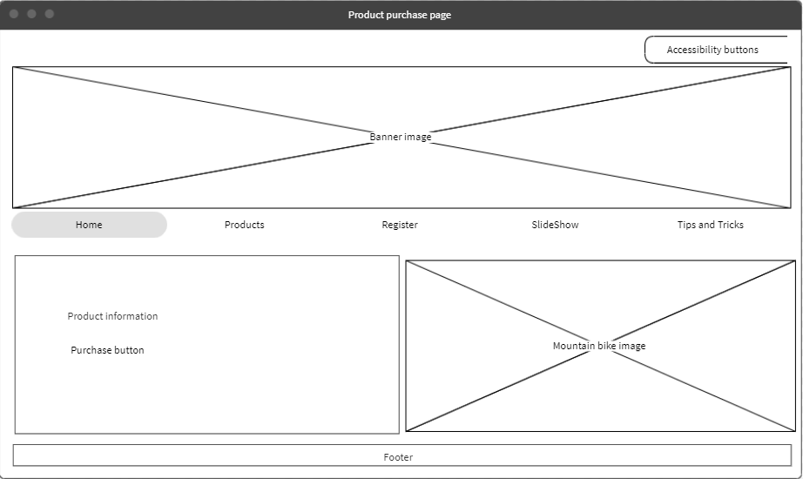

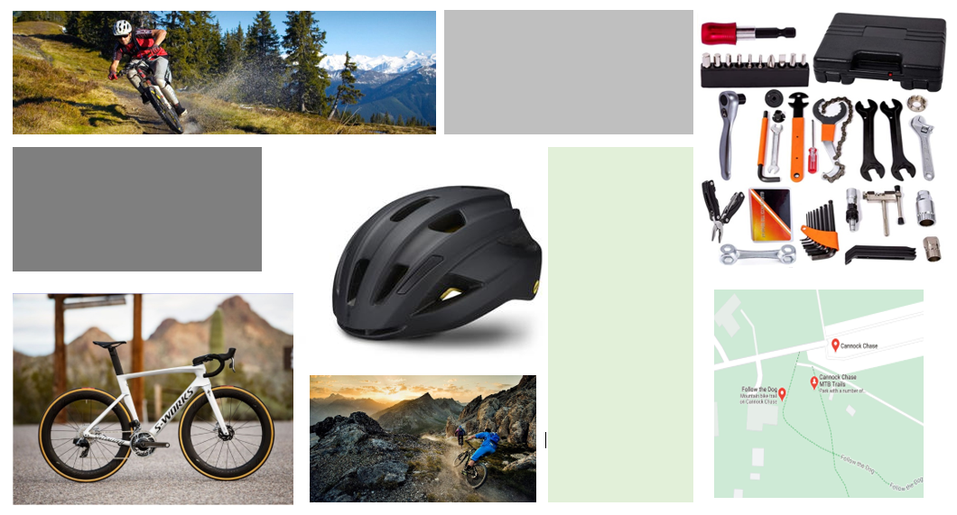Mood Board:

# Inspiration

My initial inspiration for making a biking website would be my own interest in biking. In the past I have been to many both physical and online biking shops from which I have drawn ideas for the website. One area which I gained some inspiration from is the Halford shops. These shops use very modern design choices using things such as limited colour palettes so as to make the products themselves stand out more than the shops. I’ve taken inspiration from this making sure not to overload the website with colours so that the many images of the products stand out.

Other websites I got some of my inspiration from include the Trek bikes website. Here I also saw the benefits of using a limited colour palette and how to keep the design modern. I also took some inspiration from this site on how I wanted to make the product page. Link to this site can be found in references.

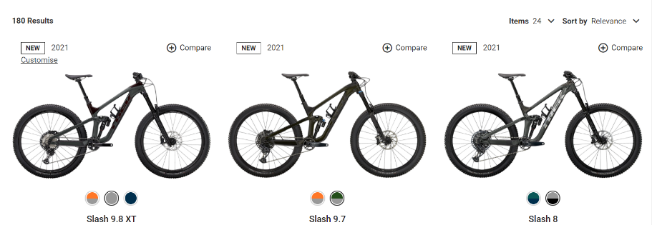

The Trek bikes product page.

# Final design

Over all I am happy with how the website turned out. The main target audience for the website was for bike enthusiasts and people who may wish to get into biking, the website made does cater for both these target markets. The website offers an opportunity to purchase biking related equipment and also offers videos and tips and tricks for new bikers. This creates a user-friendly environment which allows bikers of all skill levels to access the website.

Design wise I’m also happy with the final version. The website is fully responsive being able to fit the screen size of most devices including mobile phones. Furthermore, there are responsive features in place in areas such as the navigation bar which when made small enough will turn from a horizontal design to a vertical design making it easy to read when on smaller screens. There are also accessibility features on the website including buttons to change the font size of the navigation bar and the colour. This should help users of the website be able to read everything in the format they find best.

The website also allows for users to make an account with the website and sign up. This is done using form elements on the register page. Some of the input boxes on this register page have validation to make sure that the user doesn’t insert incorrect information which doesn’t match the requirements.

# References

* Bike helmet image used on product page:

Evans Cycles. *Bike helmets.* Available: https://www.evanscycles.com/helmets-protection/bike-helmets. Last accessed 2021.

* Bike repair kit image on product page:

Amazon. *Bike Repair kit.* Available: [https://www.amazon.co.uk/COZYROOMY-Bike-Repair-Tool-Kit/dp/B08262QVMB. Last accessed 2021](https://www.amazon.co.uk/COZYROOMY-Bike-Repair-Tool-Kit/dp/B08262QVMB.%20Last%20accessed%202021).

* Road bike used on slide show page:

Pedalsure. *10 Of The Most Expensive Road Bikes Of All Time.* Available: https://www.pedalsure.com/blog/most-expensive-road-bikes-all-time. Last accessed 2021.

* Image used in slide show and website mentioned in inspiration:

Trek. *Mountain bikes.* Available: https://www.trekbikes.com/gb/en_GB/bikes/mountain-bikes/c/B300/. Last accessed 2021.

* Bike lock used on product page:

Aldridge. *Bike lock.* Available: https://www.aldridgesecurity.co.uk/abus-0224-abus-ugrip-585-series-tactile-touch-bike-lock-chain-750mm.html. Last accessed 2020.

* Mountain bike used on product page:

Go outdoors. *Mountain bike.* Available: https://www.gooutdoors.co.uk/15904161/calibre-saw-mountain-bike-15904161/?istCompanyId=c2ec8a5d-93c1-4850-a97a-f4d89d7c99c8&istFeedId=2755fba0-7dfe-46a9-bfd0-09b37aed8b93&istItemId=wapiialqi&istBid=t&. Last accessed 2020.

* Road bike used on product page:

Ebike direct. *Road bike.* Available: https://outlet.e-bikesdirect.co.uk/bikes/adult-bikes/road-bikes/barracuda-corvus-mens-road-racing-bike-blue-14-speed-700c-59cm?gclid=CjwKCAiAxeX_BRASEiwAc1QdkVANGyvtTv3BeRK6jojl7K9gBqXIV00vG7iFaZRIEPI. Last accessed 2021.

* Child bike used on product page;

Go outdoors. *Child bike.* Available: https://www.gooutdoors.co.uk/15907227/wild-bikes-wild-18-kids-bike-15907227/?istCompanyId=c2ec8a5d-93c1-4850-a97a-f4d89d7c99c8&istFeedId=2755fba0-7dfe-46a9-bfd0-09b37aed8b93&istItemId=wapipmiax&istBid. Last accessed 2021.

* YouTube video used in product page:

Original cyclist . (2018). *Cannock Chase - Follow the Dog & Monkey Trail.* Available: https://www.youtube.com/watch?v=_dMZt7zuT18&ab_channel=OriginalCyclist. Last accessed 2021.

* Website banner image:

Free web headers. *Bicycle Racing Sports Headers.* Available: https://www.freewebheaders.com/sport/bicycle-racing-headers/. Last accessed 2020.

* Help in responsive navigation bar code:

W3schools. *Responsive Navbar with Dropdown.* Available: https://www.w3schools.com/howto/tryit.asp?filename=tryhow_js_responsive_navbar_dropdown. Last accessed 2021.

* Help with Java session storage code:

W3schools. (). *Window sessionStorage Property.* Available: https://www.w3schools.com/jsref/prop_win_sessionstorage.asp. Last accessed 2021.

* Help with form in register page:

W3schools. *HTML Tag.* Available: https://www.w3schools.com/tags/tag_form.asp. Last accessed 2021.

* Mountain bike image used in home page:

Dirt Mountain bike. (). *A buyers guide to downhill mountain bikes.* Available: https://dirtmountainbike.com/bike-reviews/downhill-bikes/buyers-guide-downhill-mountain-bikes.html. Last accessed 2020.

* Road bike used in home page:

REI co op. (). *How to Choose Road Bikes.* Available: https://www.rei.com/learn/expert-advice/how-to-choose-road-bikes.html. Last accessed 2020.